Lesson Description:

Creating a strong password that you can

remember easily

**Lesson 1**



Aims (What are you going to learn?):

You will be able to create a password for any online account and remember it without having to write it down

What you will need:

1. Equipment: computer or mobile device (e.g. laptop, desktop, mobile phone, tablet)
2. Website or application to create an account on (e.g. outlook.com, facebook.com)
3. Internet Access



Basic Skills needed:

1. Ability to access a computer
2. Ability to complete basic computer skills
3. Ability to handle basic mobile device functions
4. Able to get onto the internet

**Time Needed**: 10 minutes

Choose a sentence with at least 8 words that you could easily remember

Example:

‘How To Create A Strong Secure Computer Password’

Take the first letter of each word

Example:

‘htcasscp’



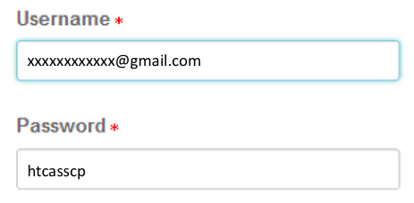

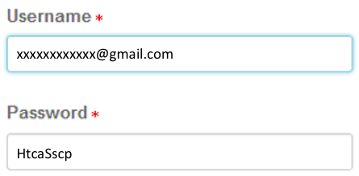

Change one or two letters to upper case

Example:

‘HtcaSscp’

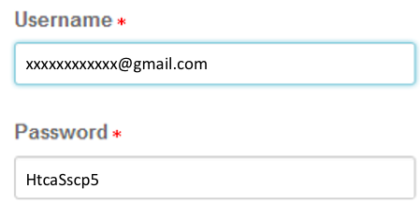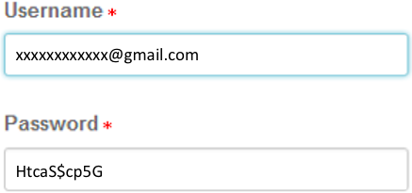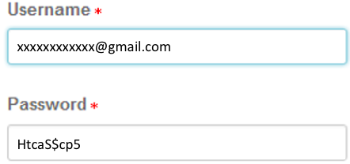

Add something unique for each account (e.g. ‘G’ for gmail or ‘B’ for banking)

Example:

‘HtcaSscp5G’

Switch one letter to a special character (e.g. ! £ $ #)

Example:

‘HtcaS$cp5’

Add a number

Example:

‘HtcaSscp5’

Keeping passwords safe issues and tips:

* Never share your password with anyone
* Make sure your password is memorable enough for you to remember it
* Try to have a different password for each account
* Do not write or store your password
* Know how to change your password if necessary

**Attention!**

If someone gains access to your password

they can take over your account

and steal your identity



|  |  |  |
| --- | --- | --- |
| Aims | Yes | No |
| I have created a password for an account |  |  |
| I have successfully created an account |  |  |
| I have remembered my password |  |  |

**Lesson Assessment**

